Cross-Sectional Studies
Alexander Beaujean, Ph.D.
Allison D. Gutierrez, Ed.S.
Baylor University
Cross-sectional studies are a type of research design used to understand time-related constancy and change in phenomena using data collected more or less simultaneously from different groups (called cohorts) of participants (e.g., people, animals, organizations). The cohorts vary on the basis of age or some other temporal phenomena (e.g., developmental stage, grade in school), so the combined sample is thought to represent the focal phenomena in the population at different times (i.e., a cross section). Differences among the cohorts are used to approximate developmental changes.
Cross-sectional studies differ from longitudinal studies because the latter require following the same participants over multiple time periods. The differences between the two types of studies are illustrated in Figure 1. Say researchers are interested in how visual-spatial ability changes in females during adolescence (i.e., 12–20 years of age). In a longitudinal study, visual-spatial data from a sample of twelve-year-old females would be collected in the first year of the study. Then, the same participants would be followed until they were 20 years old, collecting visual-spatial data from each participant at regular intervals (e.g., every 2 years in Figure 1). The study would take eight years, so to be completed in 2016 it would have to start in 2008. If a cross-sectional study was used, it could be completed in a single year (e.g., 2016 in Figure 1). It would require collecting visual-spatial data from multiple cohorts of adolescent females who were 20 (born in 1996), 18 (born in 1998), 16 (born in 2000), 14 (born in 2002), and 12 years old (born in 2004).
Cross-sectional studies have several benefits, all of which relate to how they compare to longitudinal studies. First, test-retest/practice effects are not an issue since data are only collected at one time point. Second, participants are only required to make a short-term commitment, which typically lowers attrition (i.e., dropping out of the study). Third, researchers do not have to spend resources finding participants at each time point. Fourth, they allow control over how well the sample represents the population regarding subgroups (e.g., gender, race). Fifth, they can provide information to aid in developing a subsequent longitudinal study, such as whether certain measures or procedures will be appropriate.
Despite their benefits, cross-sectional studies also have major limitations. First, they do not provide a way to capture phenomena change in participants directly. Thus, cross-sectional studies are best conceptualized as being exploratory. That is, any interpretation of the results related to development should be interpreted as hypothesis generating instead of hypothesis confirming. Second, group differences cannot be interpreted as solely reflecting developmental differences. This is because cross-sectional studies confound age effects (i.e., influences due to development) with both cohort effects (i.e., influences due to different historical experiences of the age-based groups) and time-of-data-collection effects (i.e., influences due to events that co-occur with the data collection occasion).
Cross-sectional studies can be augmented to provide stronger evidence of developmental changes. For example, two or more cross-sectional studies could be combined to create a cross-sectional sequence study. Using the example from Figure 1, the cross-sectional study comparing 12- to 20-year-olds in 2016 could be repeated in 2020 by obtaining a new sample of females in the same age groups. Another type of variation is to add a longitudinal component to a cross-sectional study, such as is done with cross-sequential, cohort-sequential, time-sequential, and accelerated longitudinal studies.
Further Reading
Appelbaum, M. I., & McCall, R. B. (1983). Design and analysis in developmental psychology. In P. H. Mussen (Ed.), Handbook of child psychology (4th ed., Vol. 1, pp. 415--476). New York, NY: Wiley.
Kraemer, H. C., Yesavage, J. A., Taylor, J. L., & Kupfer, D. (2000). How can we learn about developmental processes from cross-sectional studies, or can we? The American Journal of Psychiatry, 157, 163-171.
Schaie, K. W. (1977). Quasi-experimental research designs in the psychology of aging. In J. E. Birren & K. W. Schaie (Eds.), Handbook of the psychology of aging (pp. 39-58). New York, NY: Van Nostrand Reinhold.

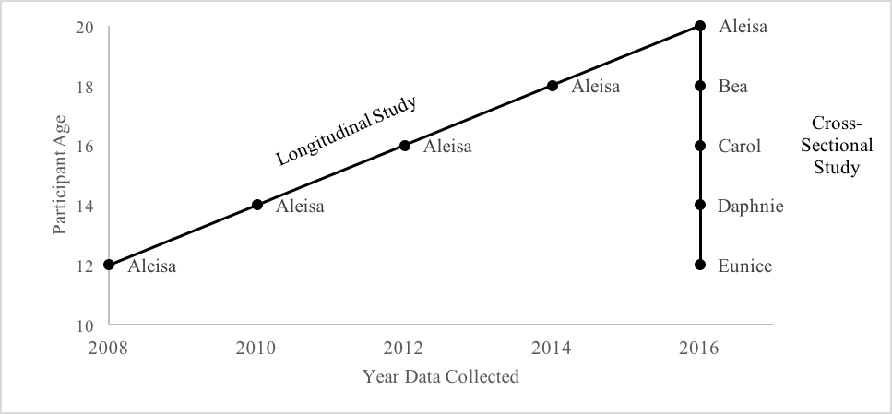
Figure 1. Illustration of design differences between longitudinal and cross-sectional studies.

