Tables
Table 1. Factor loadings for Principle Components Analysis (Varimax rotation)
 | Factor Loadings
Source of Item and Content | 1 | 2 | 3 | 4
Factor 1: Non-judge
Ffmq10R: | .787
Ffmq25R: | .786
Ffmq39R: | .746
Ffmq17R: | .733
Ffmq3R: | .704
Ffmq14R: | .657
Factor 2: Observe
Ffmq15: |  | .774
Ffmq20: |  | .761
Ffmq26: |  | .707
Ffmq31: |  | .702
Ffmq6: |  | .691
Ffmq1: |  | .622
Factor 3: Acting with Awareness
Ffmq13R: |  |  | .821
Ffmq5R: |  |  | .812
Ffmq8R: |  |  | .770
Ffmq18R: |  |  | .635
Ffmq28R: |  |  | .605
Factor 4: Describe
Ffmq27: |  |  |  | .784
Ffmq12R: |  |  |  | .757
Ffmq37: |  |  |  | .715
Ffmq32: |  |  |  | .703
Ffmq22R: |  |  |  | .583
Note. Items 2, 4, 7, 9, 11, 16R, 19, 21, 23R, 24, 29, 30R, 33, 34R, 35R, 36 and 38R were removed due to low loadings.

Table 2. Descriptive Statistics of the Argentine-Spanish version of the Five Facets Mindfulness Questionnaire
Dimensions | M | SD | Minimum | Maximum
Observe | 3.20 | .898 | 1 | 5
Describe | 3.60 | .827 | 1.40 | 5
Acting with Awareness | 2.92 | .905 | 1 | 5
Nonjudge | 3.87 | 1.06 | 1 | 5
Mindfulness | 10.57 | 2.20 | 5.13 | 16.40

Table 3. Cronbach’s alpha coefficients in Spanish and English studies
Dimensions | Present study | Mola-Gubbins study  (Peruvian) | Cebolla study (Spanish) | Manotas study  (Colombian) | Baer study (English)
Observe | 0.85 | 0.77 | 0.81 | 0.85 | 0.83
Describe | 0.83 | 0.84 | 0.91 | 0.81 | 0.91
Acting with Awareness | 0.86 | 0.86 | 0.89 | 0.83 | 0.87
Non-judge | 0.83 | 0.86 | 0.91 | 0.86 | 0.87
Mindfulness | 0.87 | 0.90 | 0.88 | 0.92 | 0.87
NB: For the current study, N = 278 and estimates are given for the 22-item scale.

Table 4. Correlations between four mindfulness factors and psychological constructs.
Dimensions | Observe | Describe | Acting with Awareness | Nonjudge
Observe | - | .421** | .288** | .148*
Describe |  | - | .331** | .224**
Acting with Awareness |  |  | - | .390**
BAI | -.053 | -.133* | -.279** | -.337**
BDI | -.212* | -.332** | -.396** | -.509**
RYFF | .236** | .365** | .333** | .444**
PSS | .041 | .077 | -.130* | -.138*
BIEPS | .192** | .295** | .371** | .371**
BAI = Beck Anxiety Inventory; BDI = Beck Depression Inventory; RYFF = Psychological Well-Being Scale; PSS = Perceived Stress Scale; BIEPS = Psychological Well-being Scale (Bienestar Psicologico).
NB. Estimates are given for the 22-item scale. *p < .05, **p <.001.
Figures
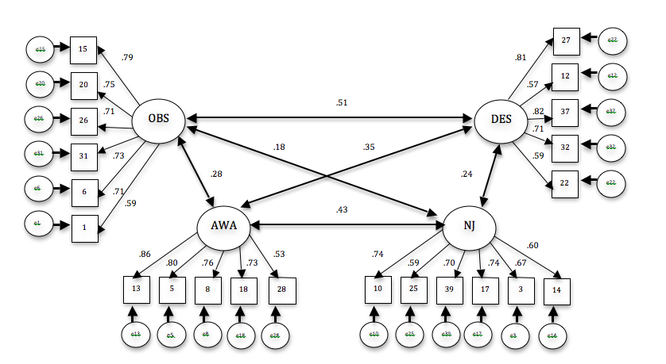
Figure 1. Model of four factors of mindfulness

