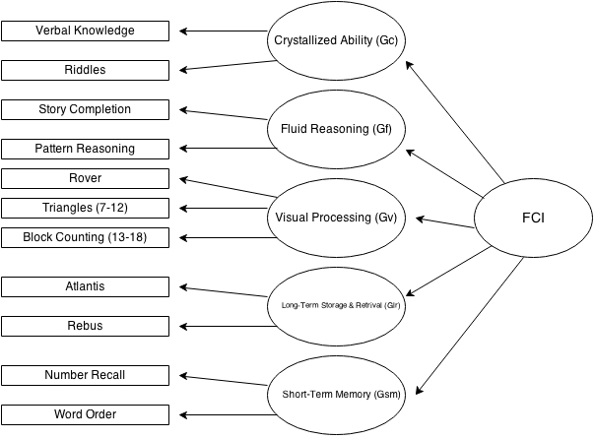
Figure 1. Indirect hierarchical Cattell-Horn-Carroll (CHC) interpretive model for the KABC-II. Adapted with permission from the KABC-II Technical Manual (Kaufman & Kaufman, 2004b).
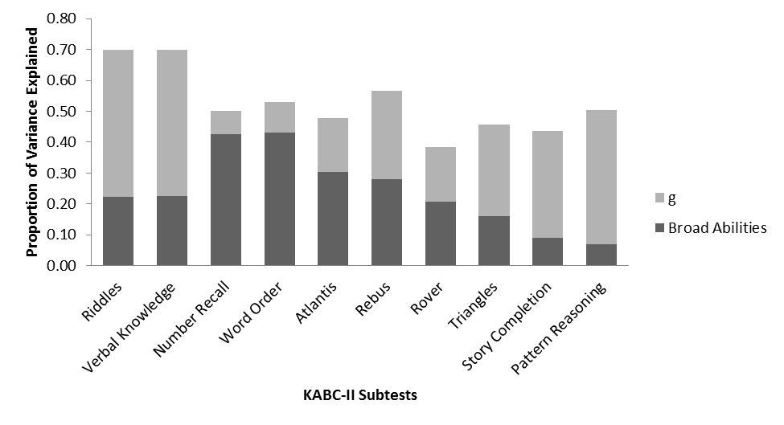
Figure 2. Proportion of KABC-II CHC model core subtests for ages 7-12 explained by the general factor and by the broad abilities.

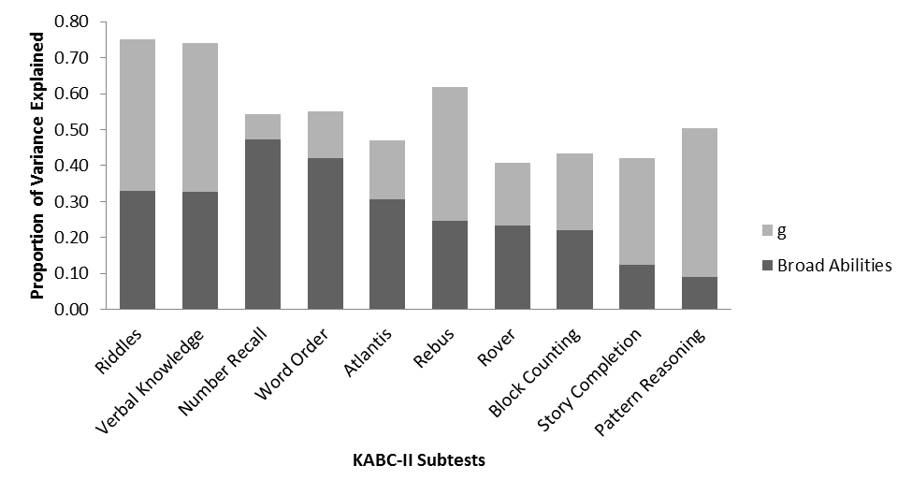
Figure 3. Proportion of KABC-II CHC model core subtests for ages 13-18 explained by the general factor and by the broad abilities.

